**__________________________________________________**

**UAC Portal v.2.7.d.e3 Emergency Fix Release**

**Deployment Document Version 1.0**

**09/13/2017**

Prepared by: Applied Intellect LLC.

**Revision History**

|  |  |  |  |
| --- | --- | --- | --- |
| DATE | VERSION | AUTHOR | DESCRIPTION |
| 09/13/2017 | 1.0 | Dilmurat Sulayman | Initial Document |
|  |  |  |  |

Table of Contents

1 Introduction 4

1.1 Project Objectives 4

1.2 Stakeholders 4

1.3 Definitions 4

2 Instructions 5

# Introduction

The purpose of this document is to provide deployment instructions for Emergency Release UAC Portal v.2.7.d.e3

## Project Objectives

The objective of effort is to fix SIR Event saving issue.

## Stakeholders

|  |  |  |  |
| --- | --- | --- | --- |
| Name | Department | Role | Sign-off Received |
|  | ORR | Sign-off |  |

## Definitions

None

# Deployment Instructions

1. Shutdown IIS

Open “Server Manager” and click on “Tools” Link

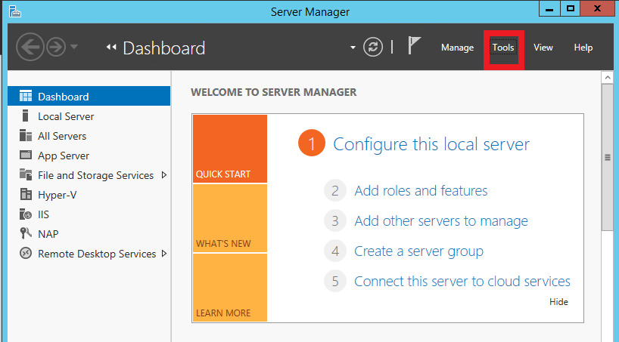

Then select “IIS Manager” from the list

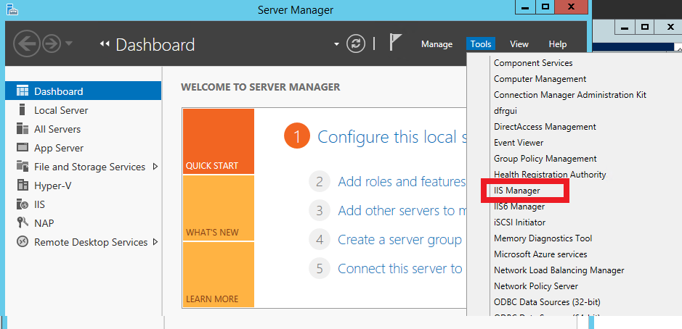

Highlight the IIS Root and Click “Stop” on the link in the right action panel

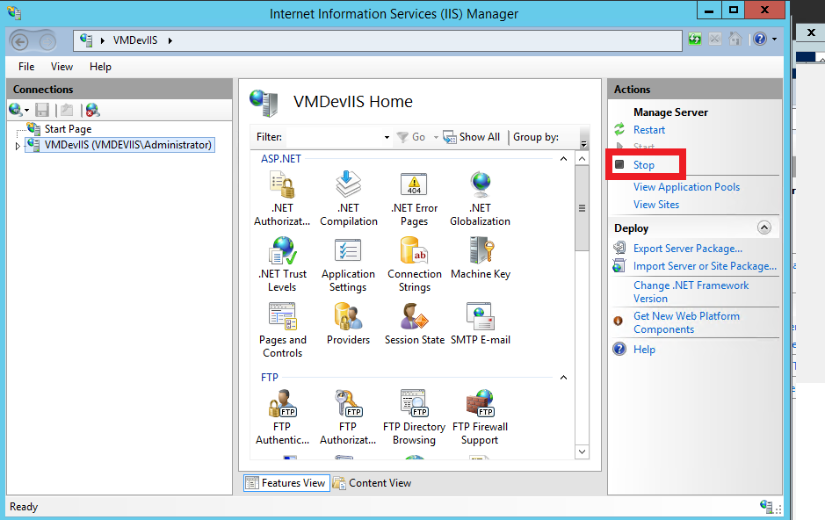

1. Unzip the contents of the Deployment package in to a temporary folder [unzipped temporary folder].
2. Back up C:\UACPortal folder
3. Copy UACWebApp.dll from [unzipped temporary folder]\UACPortal into C:\UACPortal\bin folder and overwrite existing files.
4. Copy AddEvent.aspx from [unzipped temporary folder]\Documents to C:\UACPortal folder
5. Restart IIS (See above image, click on Restart button)

